Introduction to R

Resources:

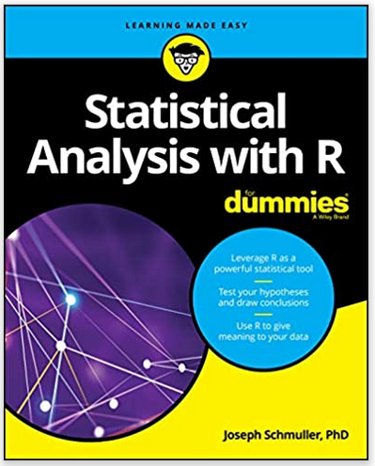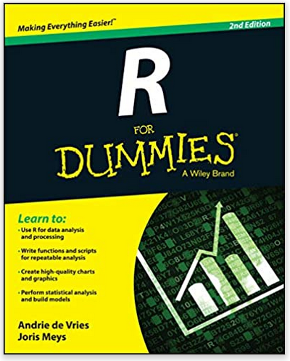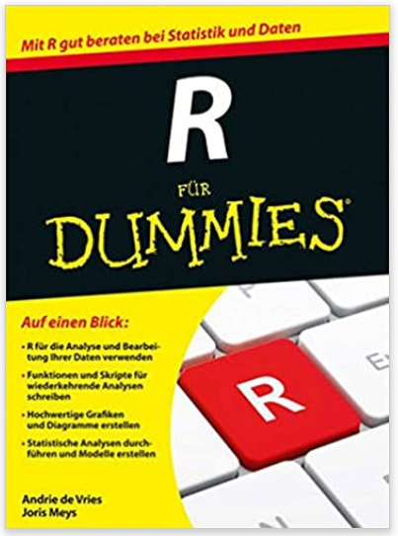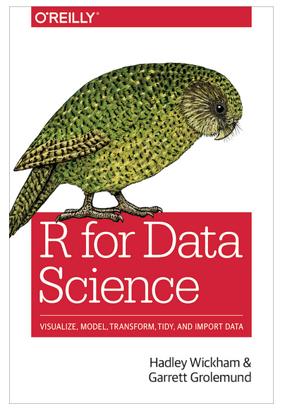
[https://r4ds.had.co.nz/introduction.html]
https://cran.r-project.org: You can find various manuals there, e.g. https://cran.r-project.org/doc/manuals/r-release/R-intro.html
https://www.r-graph-gallery.com/
https://www.data-to-viz.com/

https://github.com/kingaa/R_Tutorial and http://kingaa.github.io/R_Tutorial/

Exercises:

Ex 1:

Ex 2:

Ex 3:

Ex 4:

Ex 5:
Verify that $\sum_{i=1}^{n}{\frac{1}{n^{2}}}$ converges to $\frac{π^{2}}{6}$ as $n→∞$.

Ex 6:
Check that $\sum_{i=1}^{n}{\frac{1}{n}}$ does not converge. Calculate this sum for n=10, n=1000, n=100000, and n=10000000.

Ex 7:
In the dataframe hurricanes.csv, compute a new factor variable categorizing MinPressure_before into quartiles (1,2,3,4) (use the function “cut”).

Ex 8:
Write a function that assigns the values 1,2,…, n randomly to n people X[1], X[2],…,X[n] (Hint: use the function runif to generate random numbers).

Dataframe “england” from the R package “engsoccerdata”

Questions one could be interested in:
- What were the final standings per season (rank/position, number of games, wins, draws, losses, goals for, goals against, goal difference, points)?
- Which team won the championship the most often? (Bar chart of the most successful teams.)
- How many different teams participated in the English Premier League since its beginnings?
- What was the game with the most goals? What was the victory with the highest goal difference?
- Did the change to the 3-1-0 system introduced in 1981 lead to more decisive games? Did it lead to more goals?
- In which seasons have there been ties in the final ranking (i.e. same number of points, same number of goals, plus same number of goals for)?
- What was the smallest margin deciding between first and second place?
- What was the average number of goals per game per season? Plot over time. Standard deviation as bars.
- How big is the advantage of playing at home?

Final standings of season 1907 (https://en.wikipedia.org/wiki/1907%E2%80%9308_Football_League):
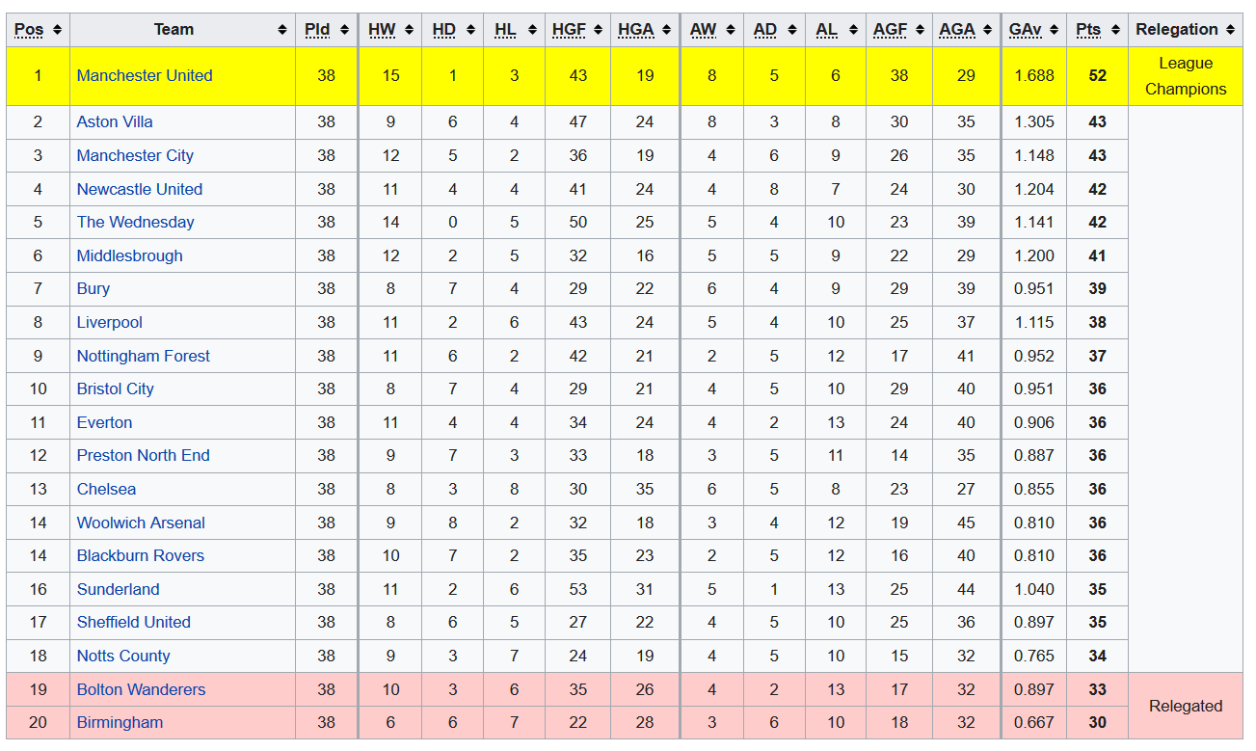
Final standings of season 1960 (https://en.wikipedia.org/wiki/1960%E2%80%9361_in_English_football):
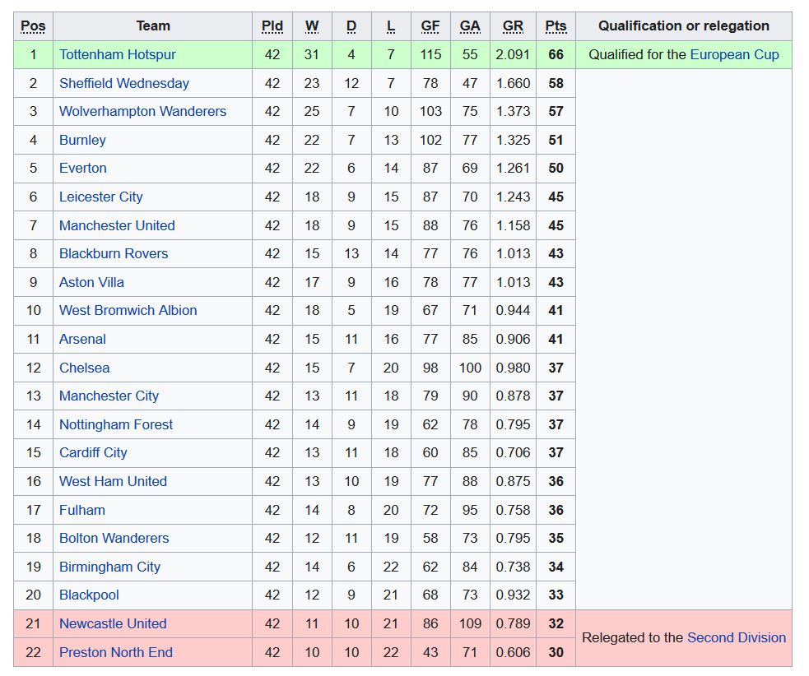

Final standings of season 2005 (https://en.wikipedia.org/wiki/2004%E2%80%9305_FA_Premier_League):
